QUALIFICATION TEST PROCEDURE

FOR THE

MULTI-OIL LEVEL INDICATOR

AUTOMATION OF THE OLS TEST BENCH

ALLEN AIRCRAFT PRODUCTS, INC.

REPORT #???

PREPARED BY: Rick Ales, Consultant, R. Ales Consulting LLC

Name, Title

APPROVED BY:

Name, Title

ALLEN AIRCRAFT PRODUCTS, INC.

RAVENNA, OHIO

Revision History

|  |  |  |  |
| --- | --- | --- | --- |
| **Rev** | **Notes** | **By** | **Date** |
| Draft 1 | Initial Draft | R. Ales | 2025/03/18 |

Table Of Contents

1.0 Purpose of Test Procedure 4

1.1 Reference Documents: 4

1.2 Notation 4

2.0 Test Plan 4

2.1 Requirements Cross Reference Summaries 4

2.2 Test 5

2.3 Analysis 5

2.4 Inspection 5

2.5 Test Results Record 5

3.0 Description of Test Item 5

3.1 General Test Data Requirements 5

3.2 Criteria for Retest 6

4.0 Test Approach 6

4.1 Test Conditions 6

4.2 Measurement Tolerances 6

4.3 Test Fluids 6

4.4 Test Setups/Equipment 6

4.5 Test Procedure Revisions 7

4.6 Allen Aircraft Contacts: 7

5.0 QTP Testing 7

5.1 Functional Requirements Test Procedures 7

5.1.1 Test Initialization 7

5.1.2 Hardware Inputs: 10

5.1.3 Hardware Outputs: 11

5.1.4 HMI: 12

5.1.5 Document management 14

5.1.6 Enter the test bench configuration parameters into XL test plan. 15

5.1.7 Enter DUT specific configuration parameters into XL test plan. 15

5.1.8 Calibration Procedure 16

5.1.9 Troubleshooting Aids 17

5.1.10 Use Case 3: Read Test Configuration -- Production Test User 18

5.1.11 Load DUT identification information 20

5.1.12 Load DUT into the test bench. 21

5.1.13 Use Case 5: Run DUT Test -- Production Test User 21

5.1.14 Use Case 5: Generate DUT Test Report -- Production Test User 26

5.2 Non - Functional Requirements Test Procedures 28

5.2.1 Level Calibration Repeatability & Accuracy 28

5.2.2 Resistance Calibration Repeatability & Accuracy 28

5.2.3 Measurement Gage R & R 28

5.2.4 Stability and Drift 28

Appendix I. Hardware Installation 28

Appendix II. Instrument Initialization 28

Appendix III. LabVIEW Application Installation 28

1. Purpose of Test Procedure

The purpose of the Qualification Testing Procedure is to demonstrate how the Allen Aircraft Automated Oil Level Sensor Test Bench, aka Multi-Level Oil Indicator (MLOI) shall perform within the requirements of Technical Requirements for the Multi-Level Oil Indicator Automated OLS Test Bench, Report #250129 (ReqSpec).

* 1. Reference Documents:

ACCEPTANCE TEST PROCEDURE FOR ALLEN 8005571.05, Report# 200333

* 1. Notation
* Means Informative

1. **Means Test Case traceable to a Requirement**

LV LabVIEW

AAP Allen Aircraft Products

QUAM AAP AS9100 Quality Manual

ATP Acceptance Test Procedure

OLS Oil Level Sensor

CIP Custom Interface PCB

DUT Device Under Test

AI Analog Input

XL MS Excel

MLOI Multi-Level Oil Indicator, designation of the automated tester described herein.

Epic 1 Single DUT automated test capability

Epic 2 MLOI capability extended to accommodate other OLS product lines.

Epic 3+ Uses the Custom Interface PCB (CIP). Also, the MLOI capability may extended to accommodate multiple sensors DUT tested simultaneously (TBD)

HW 1 Prototype phase where all items are COTS and custom configurations are achieved through breadboards or otherwise temporary connections.

HW 2 Production where custom interfaces have been designed and fit for purpose implemented, ie interface unit manufactured as a custom PCB.

<parm> Indicate the tester should supply the indicated parameter as appropriate.

1. Test Plan
   1. Requirements Cross Reference Summaries

Test cases and procedures are traceable to the requirements of the ReqSpec by being numbered with the corresponding requirement number.

Upon successful execution of this QTP, the MLOI Automated OLS Test shall be deemed suitable for ATP and production testing of the approved corresponding OLS product. The initial test shall cover EPIC 1 as defined in the ReqSpec for Elevate OLS sensor (PN 8005571.05).

* 1. Test

Verification that a requirement is met is by a thorough exercising of the item. This includes actual measurement of unit performance with calculations/analysis as required under controlled and/or recorded environment and in accordance with approved test procedures.

* 1. Analysis

The requirement is substantiated by Analysis. Analysis is the processing of accumulated results and conclusions to determine whether a requirement has been verified. The analytical results may be based on original study, or derived from lower-level examination, test, demonstration, or a formal analysis.

* 1. Inspection

Inspection is a visual examination, physical manipulation, weighing and/or measurements to verify that the hardware item conforms to the design requirements and includes review of documentation controlling configuration and requirements.

* 1. Test Results Record

The test cases shall provide space to record the results of that test case and an overall PASS/FAIL score shall be recorded. This will serve as the Test Results Record when completed and signed off by the designated stakeholders.

1. Description of Test Item

The Allen MLOI Automated OLS Test Bench is illustrated in Appendix II. The MLOI is an LabVIEW automated system intended to be a hands-free product test bench that minimizes human product evaluation by controlling the pump and data acquisition system used to precisely control the test tank oil level to a specified Test Point and measure and record the OLS response then determine if the Device Under Test response complies to the designated product ATP specification and report a PASS/FAIL status for that product at the completion of the test.

* 1. General Test Data Requirements

One MLOI Automated OLS test bench designed to comply with EPIC 1 of the ReqSpec, shall be evaluated. One or more designated and characterized OLS product will be used as DUT to evaluate the performance of the MLOI under test.

Data for each test shall be recorded on individual data sheets. Each sheet shall contain as a minimum the following:

1. Test Title: “QTP Results for MLOI Automated OLS Test Bench, EPIC 1”
2. Date of test
3. Test procedure paragraph reference
4. All pertinent environmental conditions
5. Type of fluid used and temperature (if applicable)
6. Name and signature of test operator(s)
7. Equipment, instruments, tolerances, and calibration
8. Input, output, and computed data

In addition, photographs of the test unit before and after testing, and of the test setup prior to testing must be taken and provided in the Test Report. Photographs shall be available for customer review prior to testing, if required.

Supporting data, such as a test log, a narrative history of the test and a data acquisition recording of the required test parameters (input and output), if applicable, per the test procedure, shall be made available for customer review.

* 1. Criteria for Retest

In the event of a test failure, the test shall be suspended and the cognizant <customer> representative shall be notified within 24 hours of the finding. The nature and amount of any redesign and retest shall be coordinated with and approved by <customer> prior to resumption of the test program.

1. Test Approach

Unless otherwise specified, the following general requirements shall apply to all Section 5 procedures.

* 1. Test Conditions

Unless otherwise specified, the tests shall be conducted at ambient temperatures between +70°F and +80°F and at local laboratory ambient pressure and humidity conditions up to 90% relative humidity. The ambient conditions at time of testing shall be provided on the test data sheet, as noted in Section 3.1.

* 1. Measurement Tolerances

The maximum allowable tolerance on test condition measurements shall be as follows:

1. Pressure: ± 2%
2. Temperature: ± 2°F
3. Flow: ± 2%

Other tolerances shall be as specified in the detailed procedure

* 1. Test Fluids

The MLOI test tank will use oil conforming to <test fuel spec (common name)>. The fluids for each test shall be recorded on all data sheets.

* 1. Test Setups/Equipment

Test setups are defined under the applicable sub-paragraphs of Section 5.1 herein. The Qualification Test Report shall include a complete equipment list identifying each specific instrument used for each test along with its corresponding range and accuracy.

Note: The setups illustrated are a guide. Equivalent instrument substitutes may be used as long as the measurement accuracy of the test parameter is not compromised.

* 1. Test Procedure Revisions

All test procedure revisions required during test – other than typographical errors that do not change the technical intent of the test - shall be approved in writing by the responsible AR at a minimum and included in the test report. These revisions include, but are not limited to, revisions where the initial stated objective of the procedure or method is not altered, and the means of achieving those stated goals are not altered.

* 1. Allen Aircraft Contacts:

The following list of Allen Aircraft personnel, unless otherwise noted, are responsible for the Design Testing and Quality verification of the product under test:

<name>, Project Design Engineer, email:

<name>, Test Engineer, email:

<name>, Director of Quality Assurance, email:

1. QTP Testing

Functional testing is based on an analysis of ReqSpec. Each Requirement of the ReqSpec shall be tested on a PASS/FAIL basis by the procedures described by test cases of Section 5.1, numbered corresponding to the functional Requirement being tested.

Performance testing includes but is not limited to activities such as Calibration and Gage R&R, which will be described in Section 5.2 and may deviate from the functional requirement numbering system.

* 1. Functional Requirements Test Procedures

The following test cases describe the test procedures to be used to verify the functional requirement and the success (PASS/FAIL) criteria. The tester should mark the check box if they concur; the test case passed if all check boxes are marked then the test should circle PASS otherwise circle FAIL.

Preform the following steps to load the LabVIEW application (LV), which applies to nearly all the test cases, to conduct the test procedures that follow.

Test Initialization

1. Install LabVIEW (LV) runtime as shown in Appendix III
2. Load the current version of the LV MLOI application as shown Test Case 1).

NOTE: At this point, much of the LV MLOI app functionality can be exercised in simulated mode.

1. Configure the system hardware as shown in Appendix I.
2. Initialize the instruments and motor controller as shown in Appendix II
3. All the functional tests should be run with the most current application loaded and running with all instruments online unless otherwise specified.
4. Verify both the LV application code and HW are version controlled.
5. Login to your favorite internet browser and navigate to <https://github.com/AllenAircraft/PWC-OLS/tree/main>. Contact AAP IT department for login information.

* On the code page, verify that the code under “Main” branch is populated and Release Notes are update.
* Under “Releases” to the right of the code block, verify the “Latest” release revision number corresponds to engineering documentation.

1. Verify the hardware drawings, including block diagram, schematic, assembly drawing and Gerber files are released.

* All hardware files are in the release folder at <Path file>

Tester __________________ Date ______________ PASS FAIL

1. The system shall have distinct modes, Test and Maintenance.

*We have yet to validate this requirement nor determined how to implement it.*

Tester __________________ Date ______________ PASS FAIL

1. The EPIC 1 System MAY be placed into production service with the HW1 (breadboard) hardware.
2. Inspect the Interface Board, check for loose wires, all components are reasonably secure, and strain reliefs are present on all wires that are regularly handled.

Type (circle one) Prototype PCB

* The Interface board is properly installed.

Tester __________________ Date ______________ PASS FAIL

1. Hardware status shall be indicated as Green = Good to test; Red = Bad or Fault; Yellow = Needs attention or not automatic, i.e. in simulation mode.
2. Power on the instrument power and the motor power supplies. Verify the DataQ, Motor controller and Laser USB port are connected to the USB Hub and the USB Hub is connected to the Workstation USB port. See the hardware configuration procedure in Appendix II.
3. On the workstation, right-click the start bar and select Device Manager. Verify that each of the units is recognized by the Device Manager. If not see the installation procedure in Appendix II.

* Verify that the three devices are shown in the Device Manager as shown above.

1. Open the LV app if the LV app is not running, click the run button.

* Verify all three status lights are GREEN.

1. Disconnect the USB hub from the Workstation.

* Verify all three status lights are YELLOW.

1. Turn OFF the simulated mode by pressing the SIM button

* Verify all three status lights are RED.

Tester __________________ Date ______________ PASS FAIL

Hardware Inputs:

1. ChA and ChB resistance measurement 0-1700Ω +/- 1%

Equipment required:

Volt/ohm meter (VOM);

100Ω and 1KΩ 0.05% Reference Resistors (may be present on the Interface board).

2kΩ bulk resistor.

1. If the resistance calibration is not up to date, then perform a Resistance calibration. See Section 5.2.2.
2. Run the MLOI app. Using the VOM measure and record the *Ref* value of each reference resistor.
3. Connect each resistor to Ch A (orange and black clip leads), and note the reading for each resistor value.
4. Connect each resistor to Ch B (Red and Yellow clip lead), and note the *Test* reading for each resistor value.
5. Calculate and note the error for the 100Ω and 1kΩ resistors as:

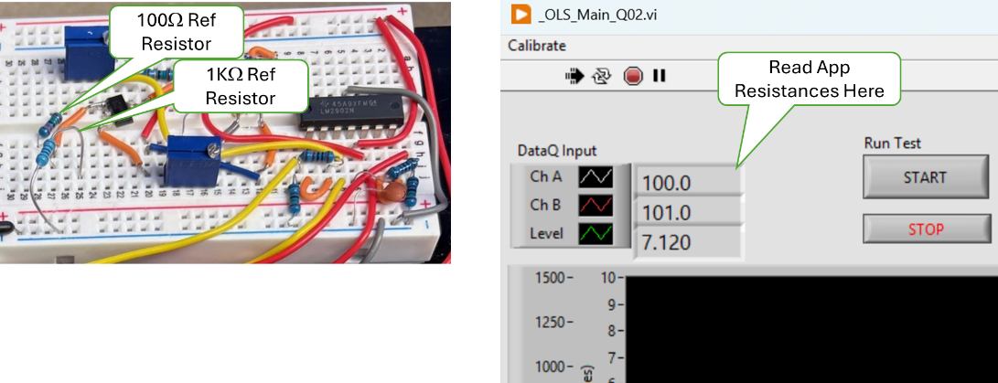

Reference Resistors and Measurement Readout.

Results

|  |  |  |  |  |  |
| --- | --- | --- | --- | --- | --- |
| **Ch** | **100Ω** | **100Ω Error** | **1kΩ** | **1kΩ Error** | **2KΩ** |
| REF |  |  |  |  |  |
| CHA |  |  |  |  |  |
| CHB |  |  |  |  |  |

* Both the 100Ω and 1KΩ Error for ChA is less than 1.0%.
* Both the 100Ω and 1KΩ Error for ChB is less than 1.0%.
* Both ChA and ChB read more 1.7KΩ or more for the 2KΩ resistor.

Tester __________________ Date ______________ PASS FAIL

1. ChA and ChB Current Source 14.7 mA +/- 0.05%

Equipment required:

Ammeter (AM);

100Ω and 1KΩ reference resistors.

1. Set the AM to the 100mA range and ensure that the probes are set to read current.
2. Connect the AM + (pos) lead to the ChA Orange lead and connect he AM – (neg) lead to the + side of the 100Ω reference resistor, ensure the other end of the reference resistor is connected to ground.
3. Record the current reading the current. ___________________ mA
4. Connect the AM + (pos) lead to the ChA Red lead and connect he AM – (neg) lead to the + side of the 1kΩ reference resistor, ensure the other end of the reference resistor is connected to ground.
5. Record the current reading the current. ___________________ mA

* The current reading (*X*) for ChA was 14.693 <= *X* <= 14.707 mA
* The current reading (*X*) for ChB was 14.693 <= *X* <= 14.707 mA

Tester __________________ Date ______________ PASS FAIL

1. Resistance measurement calibration check shall be enforced monthly.
2. In the Win11 search bar type “RegEdit” and start the Registry Editor.
3. In the folder tree in the left pane navigate to:

Computer\HKEY_CURRENT_USER\Allen AirCraft\Elevate OLS Test

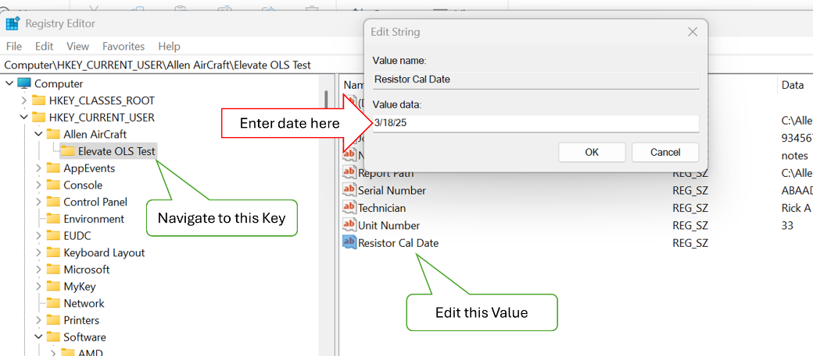

1. Open the Elevate OLS Test Key folder, then click on Resistor Cal Date, Edit.
2. In the Edit popup add today’s date + 30 days. Start the MLOI application.

* Verify there was no prompt to perform a resistor calibration.

1. Stop the MLOI application
2. Edit the Resistor Cal Date registry key to be today’s date + 31 days. Start the MLOI application

* Verify the user was prompted to perform a resistor calibration.

1. Stop the MLOI application.

Tester __________________ Date ______________ PASS FAIL

1. Level measurement (Process Variable PV) 2.5 to 8.5 inches +/- 0.0005”
2. Run the Level Accuracy and Repeatability evaluation defined in Section 5.2.1.

* Level accuracy was successfully demonstrated during the Accuracy and Repeatability evaluation of Section 5.2.1.

Tester __________________ Date ______________ PASS FAIL

1. Level measurement calibration check shall be enforced daily
2. In the Win11 search bar type “RegEdit” and start the Registry Editor.
3. In the folder tree in the left pane navigate to:

Computer\HKEY_CURRENT_USER\Allen AirCraft\Elevate OLS Test

1. Open the Elevate OLS Test Key folder, then click on Level Cal Date, Edit.
2. In the Edit popup add today’s date. Start the MLOI application.

* Verify there was no prompt to perform a Level calibration.

1. Stop the MLOI application
2. Edit the Resistor Cal Date registry key to be today’s date + 1 days. Start the MLOI application

* Verify the user was prompted to perform a resistor calibration.

1. Stop the MLOI application.

Tester __________________ Date ______________ PASS FAIL

Hardware Outputs:

1. Level control (Set Point SP) 2.5 to 8.5 inches +/- 0.002”
2. Run the Level Accuracy and Repeatability evaluation defined in Section 5.2.1.

* Level accuracy was successfully demonstrated during the Accuracy and Repeatability evaluation of Section 5.2.1.

Tester __________________ Date ______________ PASS FAIL

1. Level control shall be assessment shall be enforced annually.
2. In the Win11 search bar type “RegEdit” and start the Registry Editor.
3. In the folder tree in the left pane navigate to:

Computer\HKEY_CURRENT_USER\Allen AirCraft\Elevate OLS Test

1. Open the Elevate OLS Test Key folder, then click on Level Control Assess Date, Edit.
2. In the Edit popup add today’s date + 1 year. Start the MLOI application.

* Verify there was no prompt to perform a Level calibration.

1. Stop the MLOI application
2. Edit the Level Control Assess Date registry key to be today’s date + 1 day and + 1 year. Start the MLOI application

* Verify the user was prompted to perform a assess the Level Control.

1. Stop the MLOI application.

Tester __________________ Date ______________ PASS FAIL

HMI:

NOTE: The HMI tests are evaluations of software requirements and may be evaluated in either normal or simulated modes.

1. Shall provide a one-button means for starting the automated test.
2. Click on the MLOI Desktop icon.

* Verify the application open and running and TEST State Out is in MANUAL mode.

1. Close the information dialog. Click on the Run Test START button.

* Verify the Test protocol starts, the Run Test button is RUNNING and highlighted Green and TEST State Out is in START
* Verify after the Level (green plot) reaches EMPTY (bottom of plot), TEST State Out becomes Pre-Test Fill.
* Verify after a few seconds, the resistor ladder is being plotted.

1. Click on the Run Test button..

* Verify that Run Test button returns to gray START, the test protocol stops and the Test State Out indicates MANUAL mode.

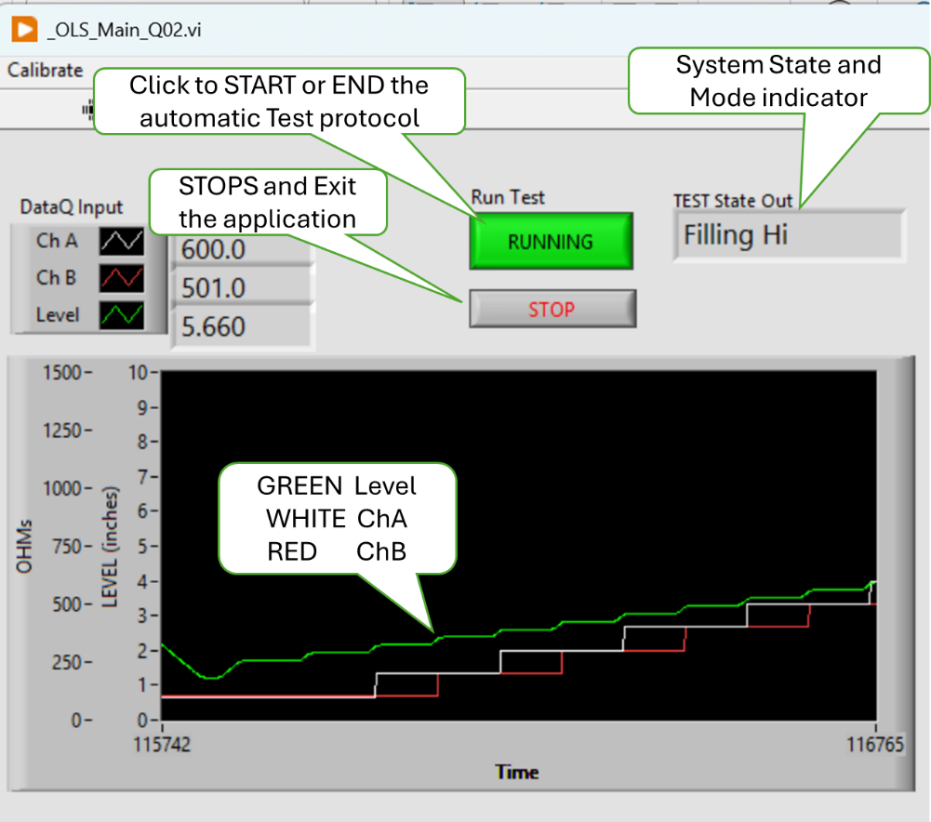

Tester __________________ Date ______________ PASS FAIL

1. Shall provide a means to manually control the Tank Level.
2. Place the Simulate button to ON (green)
3. . Sete the JOG buttons to ON (green); the FILL and DRAIN buttons to OFF (gray) and select STOP in the Speed dropdown.

* Verify that the SP Slider has no control over PV
* Verify that the SP Slider and its digital output read approximately the same value over the slider range.

1. Press the FILL Button

* Verify that the FILL button is ON (green) and the DRAIN button is OFF (gray)
* Verify that PV slider and its digital output read approximately the same value over the slider range.
* Verify the Level value (above the plot) and the PV digital output read the same Level value.
* Verify that Level and PV values decrease towards FULL and the Green plot rises.

1. Change the Pump Speed to CREEP, SLOW, FAST.

* Verify that Level, PV and the green plot respond corresponding to the selected Speed. FAST is faster than SLOW which is faster than CREEP which is faster than STOP.

1. Change the Pump Speed to Stop

* Verify the Level, PV and Plot stop changing.
* Verify that both FILL and DRAIN buttons are OFF (gray).

1. Press the DRAIN button

* Verify that the FILL button is OFF (gray) and the DRAIN button is ON (green)
* Verify that PV slider and its digital output read approximately the same value over the slider range.
* Verify the Level value (above the plot) and the PV digital output read the same Level value.
* Verify that Level and PV values increases towards EMPTY and the Green plot falls.

1. Change the Pump Speed to CREEP, SLOW, FAST.

* Verify that Level, PV and the green plot respond corresponding to the selected Speed. FAST is faster than SLOW which is faster than CREEP which is faster than STOP.
* Verify that both FILL and DRAIN buttons are OFF (gray).

1. Alternate pushing FILL and DRAIN buttons

* Verify Speed goes to SLOW.
* Verify Speed can be changed in both FILL and DRAIN modes.
* Verify FILL and DRAIN can NOT be both ON (gray) at the same time.

1. Set Pump JOG to OFF (gray). Set the SP slider to various Level Values.

* Verify the Level value, PV and Plot all drive toward the SP values and stop within 5% of the SP value.

1. Ensure that the Laser and the Pump status lights are GREEN. Then Set the Simulate button to OFF (gray).
2. Repeat Steps 2 through 8

* Verify the actual tank performed the same as the simulated tank.

Tester __________________ Date ______________ PASS FAIL

1. Shall display the current ChA and ChB measurement to 0.1Ω
2. Shall display the level measurement to 0.001”
3. Shall provide time-based plot of the resistance for both ChA and ChB, and tank Level.
4. With the MLOI app running, connect the Orange clip lead to the 100Ω test resistor and the Red clip lead to the 1KΩ test resistor.

* Verify that ChA Value and the white plot on the chart indicates about 100.0
* Verify that ChB Value and the red plot on the chart indicates about 1000.0
* Verify that the Level reading is to three (3) decimal places and is displayed as green plot on the chart.

1. Connect the Orange clip lead to the 1KΩ test resistor and the Red clip lead to the 100Ω test resistor.

* Verify that ChA Value and the white plot on the chart indicates about 1000.0
* Verify that ChB Value and the red plot on the chart indicates about 100.0
* Verify that the Level reading is to three (3) decimal places and is displayed as green plot on the chart.

Tester __________________ Date ______________ PASS FAIL

1. Shall display instrument status.

NOTE: This is a duplicate, see Test Case 4).

1. Shall display the Pass/Fail status and progress of the test.
2. With the MLOI app running, Press the Run Test button to Running (green). Let the test progress.

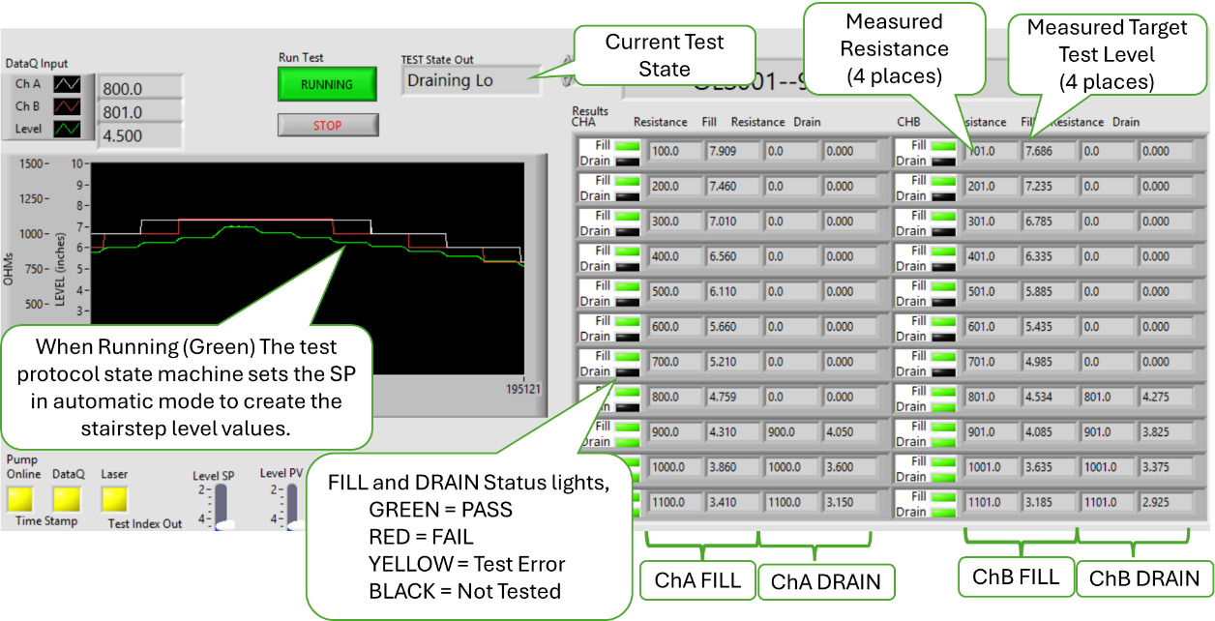

* Verify that Test State Out is sequencing through the test protocol.
* Verify the plots on the charts indicate the test protocol progress as stair step plots.
* Verify both the Fil and Drain status lights indicate test status as the test progresses.
* Verify the Resistor and Fill/Drain field are populated with the ChA, ChB and Level PV values as the test progresses.

1. When the test is completed, (DONE state) at the prompt press SAVE button then exit the test.

* Verify that a report is generated and saved as an XL workbook and the app closes.

Tester __________________ Date ______________ PASS FAIL

1. Shall provide a menu means to launch secondary methods.

NOT sure what I meant? Perhaps the Calibrate menu, or read registry action all TBD.

Tester __________________ Date ______________ PASS FAIL

1. Shall not require operator to enter redundant information.
2. With the app closed, click on the desktop icon.

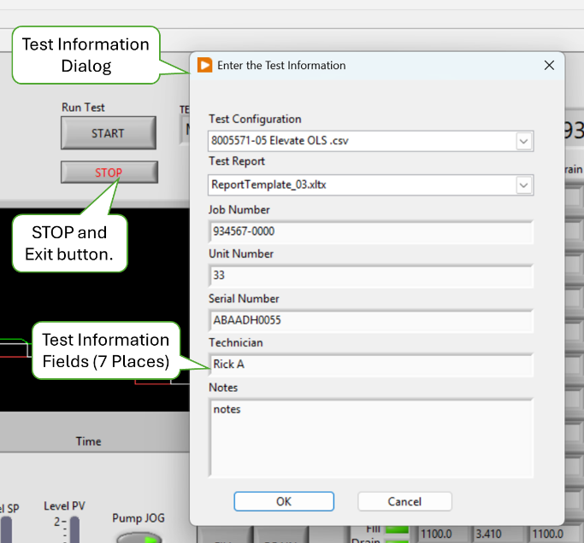

* Verify the test information dialog opens.

1. Note the values of each field, then change each test information field value.
2. Click OK to close the dialog then Click the app STOP button to exit the app.
3. With the app closed, click on the desktop icon.

* Verify that the Test information dialog opens and contains the new test information values entered in step 2.

Tester __________________ Date ______________ PASS FAIL

Document management

1. The test plan-> Configuration File shall be an XL workbook named to be traceable the test protocol implemented.
2. The test plan-> Configuration File shall be version controlled in the Test repository per AAP QUAM.
3. There shall be a means to add/include the test plan-> Configuration File path into the user prompt.
4. On the AAP network, navigate to the Configuration document in the form of an XL workbook (Config File) located in AAP Controlled Documents Vault located at M:\<Path to Controlled Documents Vault>.

* Verify that the Config File was approved by Engineering and Quality Assurance.
* Verify that the current version of the Config File is saved in the AAP Controlled Documents Vault located at M:\<Path to Controlled Documents Vault>.
* Verify the Config File name contains the common part number of the product associated with this test protocol configuration.

1. With the app closed, click on the desktop icon
2. If the Configuration File Path does not show the desired product test config file selected or not the path of the controlled document, then perform Steps 4 through 5.
3. Click on Test Configuration to open the dropdown list of files.

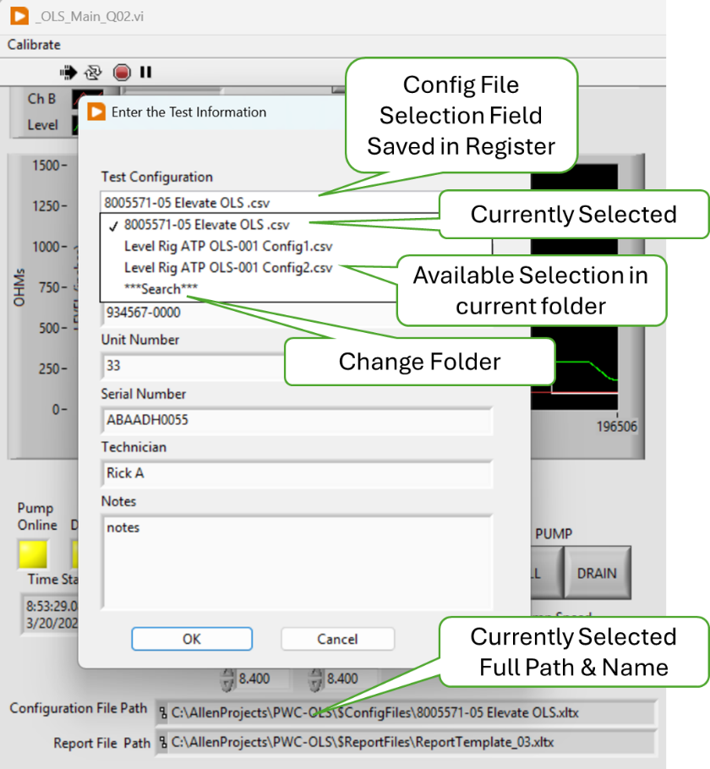

1. Click on “**Search**” in the dropdown list to navigate to a new folder and open the selected Config file. Press OK.

* Verify the select path and file are displayed in the Configuration File Path indicator.

1. Close and re-open the application

* Verify the path shown in the Configuration File Path indicator persists from one app activation to the next.

1. Using the Test Configuration drop down change Config file from the list presented. Press OK.

* Verify the select path and file are displayed in the Configuration File Path indicator.

1. Close and re-open the application

* Verify the path shown in the Configuration File Path indicator persists from one app activation to the next.

Tester __________________ Date ______________ PASS FAIL

Enter the test bench configuration parameters into XL test plan-> Configuration File.

1. The test plan-> Configuration File shall contain the configurable test bench parameters as determined by the test bench design.
2. Tabular data should be a copy and paste operation from the reference Test Document (ATP) into the XL test plan-> Configuration File document for loading as a LV parameter.
3. The test plan-> Configuration File shall contain the referenced test protocol test bench parameters as determined by the test bench design.
4. It should be a copy and paste operation to include the Test bench parameters into the XL test plan-> Configuration File document.
5. The Test Plan shall contain a template of each test report generated on a separate sheet in the test plan XL workbook.
6. The test plan-> Configuration File shall be capable of containing multiple templates to accommodate recording multiple test points or variations of test protocol.
7. Find all the above required features. <Yada Yada Yada>

* Verify all the above required features.

Tester __________________ Date ______________ PASS FAIL

Calibration Procedure

1. There shall be a means to perform a 2-point linear calibration on each AI input.
2. Run the Resistance Accuracy and Repeatability evaluation defined in Section 5.2.2.

* Resistance accuracy was successfully demonstrated during the Accuracy and Repeatability evaluation of Section 5.2.2.

Tester __________________ Date ______________ PASS FAIL

1. There shall be a means to perform a 5-point linear calibration the Level Sensor.
2. Run the Level Accuracy and Repeatability evaluation defined in Section 5.2.1.

* Level accuracy was successfully demonstrated during the Accuracy and Repeatability evaluation of Section 5.2.1.

Tester __________________ Date ______________ PASS FAIL

1. These Bench calibrations shall be saved and linked to the Test Plan.
2. On the Win11 LV workstation, navigate to C: \\<Root path of Application>\$Calibration folder. Open file “Cal Level RnR nnnn.xlsx”.

* Verify that both the level and resistance calibration raw values are recorded sequentially each time a calibration is run thus maintaining a calibration history.
* Verify the calibration parameters, slope (*m*) and offset (*b*) are calculated from the raw calibration data.

1. Navigate to the M:\<AAP controlled doc vault>\$ConfigFiles and open the current <Config File>.xlsx.

* Verify that the calibration parameters *(m* and *b*) and calibration date are stored as the default for each active channel requiring calibration.

Tester __________________ Date ______________ PASS FAIL

Troubleshooting Aids

1. There shall be a means for manually setting the tank level.
2. Verify the hardware drawings, including block diagram, schematic, assembly drawing and Gerber files are released.

* All hardware files are in the release folder at <Path file>

Tester __________________ Date ______________ PASS FAIL

1. Each instrument (DataQ, Keyence) shall provide a health indicator.
2. Verify the hardware drawings, including block diagram, schematic, assembly drawing and Gerber files are released.

* All hardware files are in the release folder at <Path file>

Tester __________________ Date ______________ PASS FAIL

1. There shall be a simulated mode that provides simulated instrument input and Level response to be used with debugging.
2. Verify the hardware drawings, including block diagram, schematic, assembly drawing and Gerber files are released.

* All hardware files are in the release folder at <Path file>

Tester __________________ Date ______________ PASS FAIL

1. There shall be a test vector mode that reads and processes AEPS type test data to validate the system processing algorithm.
2. Verify the hardware drawings, including block diagram, schematic, assembly drawing and Gerber files are released.

* All hardware files are in the release folder at <Path file>

Tester __________________ Date ______________ PASS FAIL

Use Case 3: Read Test Configuration -- Production Test User

1. LV program must launch from PC desktop ICON in application running mode.
2. Verify the hardware drawings, including block diagram, schematic, assembly drawing and Gerber files are released.

* All hardware files are in the release folder at <Path file>

Tester __________________ Date ______________ PASS FAIL

1. Maintenance User exclusive controls and Indicators shall be hidden in Test mode.
2. Verify the hardware drawings, including block diagram, schematic, assembly drawing and Gerber files are released.

* All hardware files are in the release folder at <Path file>

Tester __________________ Date ______________ PASS FAIL

1. All Test Parameters options must be presented in the form of a discrete choice (i.e. dropdown, pick list, radio button etc.).
2. Verify the hardware drawings, including block diagram, schematic, assembly drawing and Gerber files are released.

* All hardware files are in the release folder at <Path file>

Tester __________________ Date ______________ PASS FAIL

1. Path to valid XL test plans shall be saved in a non-volatile means and presented as a choice by Test name configured by the Maintenance User.
2. Verify the hardware drawings, including block diagram, schematic, assembly drawing and Gerber files are released.

* All hardware files are in the release folder at <Path file>

Tester __________________ Date ______________ PASS FAIL

1. The system shall be configured, initialized and shall report any NOT READY to test status: i.e. no functional instrument, out of calibration data, error reading test Plan etc.).
2. Verify the hardware drawings, including block diagram, schematic, assembly drawing and Gerber files are released.

* All hardware files are in the release folder at <Path file>

Tester __________________ Date ______________ PASS FAIL

Load DUT identification information

1. Engineering shall provide an ATP Test report template that provides the reference for the required DUT Test Information.
2. Verify the hardware drawings, including block diagram, schematic, assembly drawing and Gerber files are released.

* All hardware files are in the release folder at <Path file>

Tester __________________ Date ______________ PASS FAIL

1. There shall be a single dialog box to enter the required DUT test information.
2. Verify the hardware drawings, including block diagram, schematic, assembly drawing and Gerber files are released.

* All hardware files are in the release folder at <Path file>

Tester __________________ Date ______________ PASS FAIL

1. The DUT information input shall be displayed and request conformation, in the form of an “are you sure?” type prompt with a YES, NO choice response. On NO reply, the user must be able to update that input which shall be retained but editable.
2. Verify the hardware drawings, including block diagram, schematic, assembly drawing and Gerber files are released.

* All hardware files are in the release folder at <Path file>

Tester __________________ Date ______________ PASS FAIL

Load DUT into the test bench.

1. On YES reply, the system shall perform a continuity check to indicate ready to test if continuity is detected otherwise indicate not ready for test.
2. Verify the hardware drawings, including block diagram, schematic, assembly drawing and Gerber files are released.

* All hardware files are in the release folder at <Path file>

Tester __________________ Date ______________ PASS FAIL

1. The test status indicator may provide a tool tip as to the not ready issue.
2. Verify the hardware drawings, including block diagram, schematic, assembly drawing and Gerber files are released.

* All hardware files are in the release folder at <Path file>

Tester __________________ Date ______________ PASS FAIL

Use Case 5: Run DUT Test -- Production Test User

1. The Test protocol shall implement the ACCEPTANCE TEST PROCEDURE FOR ALLEN 8005571.05, Report# 200333. (attached)
2. Verify the hardware drawings, including block diagram, schematic, assembly drawing and Gerber files are released.

* All hardware files are in the release folder at <Path file>

Tester __________________ Date ______________ PASS FAIL

1. The oil level shall be cycled from empty to full to empty prior to testing.
2. Verify the hardware drawings, including block diagram, schematic, assembly drawing and Gerber files are released.

* All hardware files are in the release folder at <Path file>

Tester __________________ Date ______________ PASS FAIL

1. The oil level shall be filled from empty to the Target Test Point.
2. Verify the hardware drawings, including block diagram, schematic, assembly drawing and Gerber files are released.

* All hardware files are in the release folder at <Path file>

Tester __________________ Date ______________ PASS FAIL

1. The Resistance shall be measured after any level variations subside to the specified criteria.
2. Verify the hardware drawings, including block diagram, schematic, assembly drawing and Gerber files are released.

* All hardware files are in the release folder at <Path file>

Tester __________________ Date ______________ PASS FAIL

1. If the measured resistance is within the specified tolerance, the test at this level is PASS, else a FAIL Shall be logged.
2. Verify the hardware drawings, including block diagram, schematic, assembly drawing and Gerber files are released.

* All hardware files are in the release folder at <Path file>

Tester __________________ Date ______________ PASS FAIL

1. The above three steps are repeated for each Low Fill Limit alternating between measuring ChA and ChB.
2. Verify the hardware drawings, including block diagram, schematic, assembly drawing and Gerber files are released.

* All hardware files are in the release folder at <Path file>

Tester __________________ Date ______________ PASS FAIL

1. The oil level shall be drained from full to the Target Test Point.
2. Verify the hardware drawings, including block diagram, schematic, assembly drawing and Gerber files are released.

* All hardware files are in the release folder at <Path file>

Tester __________________ Date ______________ PASS FAIL

1. The Resistance shall be measured after any level variations subside to the specified criteria.
2. Verify the hardware drawings, including block diagram, schematic, assembly drawing and Gerber files are released.

* All hardware files are in the release folder at <Path file>

Tester __________________ Date ______________ PASS FAIL

1. If the measured resistance is within the specified tolerance, the test at this level is PASS, else a FAIL Shall be logged.
2. Verify the hardware drawings, including block diagram, schematic, assembly drawing and Gerber files are released.

* All hardware files are in the release folder at <Path file>

Tester __________________ Date ______________ PASS FAIL

1. The above Three steps are repeated for each High Drain Limit, alternating between measuring ChA and ChB.
2. Verify the hardware drawings, including block diagram, schematic, assembly drawing and Gerber files are released.

* All hardware files are in the release folder at <Path file>

Tester __________________ Date ______________ PASS FAIL

1. The DUT shall be recorded as PASS if no FAILs are recorded.
2. Verify the hardware drawings, including block diagram, schematic, assembly drawing and Gerber files are released.

* All hardware files are in the release folder at <Path file>

Tester __________________ Date ______________ PASS FAIL

1. The test status shall graphically display Ch A & Ch B resistance in ohms and display the Level in inches.
2. Verify the hardware drawings, including block diagram, schematic, assembly drawing and Gerber files are released.

* All hardware files are in the release folder at <Path file>

Tester __________________ Date ______________ PASS FAIL

1. All three traces shall be scaled so they are presented overlayed at a similar size. The Chart scale is a configurable test parameter.
2. Verify the hardware drawings, including block diagram, schematic, assembly drawing and Gerber files are released.

* All hardware files are in the release folder at <Path file>

Tester __________________ Date ______________ PASS FAIL

1. A display shall indicate each Switch status as NOT TESTED (gray), PASS (green) or FAIL (red) or ERROR (yellow) for a detected procedural problem.
2. Verify the hardware drawings, including block diagram, schematic, assembly drawing and Gerber files are released.

* All hardware files are in the release folder at <Path file>

Tester __________________ Date ______________ PASS FAIL

1. A display shall indicate the measured Target Test Point and the actual resistance measured there.
2. Verify the hardware drawings, including block diagram, schematic, assembly drawing and Gerber files are released.

* All hardware files are in the release folder at <Path file>

Tester __________________ Date ______________ PASS FAIL

1. The User must have the means to monitor the Test bench health during testing.
2. Verify the hardware drawings, including block diagram, schematic, assembly drawing and Gerber files are released.

* All hardware files are in the release folder at <Path file>

Tester __________________ Date ______________ PASS FAIL

1. Users must have a means to PAUSE the test.
2. Verify the hardware drawings, including block diagram, schematic, assembly drawing and Gerber files are released.

* All hardware files are in the release folder at <Path file>

Tester __________________ Date ______________ PASS FAIL

1. Users must have a means to ABORT the test.
2. Verify the hardware drawings, including block diagram, schematic, assembly drawing and Gerber files are released.

* All hardware files are in the release folder at <Path file>

Tester __________________ Date ______________ PASS FAIL

1. Users must have the option to RERUN the test.
2. Verify the hardware drawings, including block diagram, schematic, assembly drawing and Gerber files are released.

* All hardware files are in the release folder at <Path file>

Tester __________________ Date ______________ PASS FAIL

1. Users must have the option to run the level in manual or automatic modes.
2. Verify the hardware drawings, including block diagram, schematic, assembly drawing and Gerber files are released.

* All hardware files are in the release folder at <Path file>

Tester __________________ Date ______________ PASS FAIL

1. The default test mode is automatic.
2. Verify the hardware drawings, including block diagram, schematic, assembly drawing and Gerber files are released.

* All hardware files are in the release folder at <Path file>

Tester __________________ Date ______________ PASS FAIL

Use Case 5: Generate DUT Test Report -- Production Test User

1. The Test results and the Product information for each test shall be saved in one XL workbook at the option of the operator.
2. Verify the hardware drawings, including block diagram, schematic, assembly drawing and Gerber files are released.

* All hardware files are in the release folder at <Path file>

Tester __________________ Date ______________ PASS FAIL

1. The ATP Test Report shall be on one sheet labeled “ATP Report” as specified in the Report Template supplied by Engineering.
2. Verify the hardware drawings, including block diagram, schematic, assembly drawing and Gerber files are released.

* All hardware files are in the release folder at <Path file>

Tester __________________ Date ______________ PASS FAIL

1. The time in 50ms intervals, ChA and ChB resistance in ohms and Level in inches shall be recorded and plotted on a sheet labeled “Raw Data.”
2. Verify the hardware drawings, including block diagram, schematic, assembly drawing and Gerber files are released.

* All hardware files are in the release folder at <Path file>

Tester __________________ Date ______________ PASS FAIL

1. The third sheet shall be labeled “Analysis” and include the actual level at which the Switch Point occurred (LSWP refer to figure 2).
2. Verify the hardware drawings, including block diagram, schematic, assembly drawing and Gerber files are released.

* All hardware files are in the release folder at <Path file>

Tester __________________ Date ______________ PASS FAIL

1. The sheet labeled “Analysis” shall include identification of “double actuations” (definition TBD) and slow “rise time” (definition TBD).
2. Verify the hardware drawings, including block diagram, schematic, assembly drawing and Gerber files are released.

* All hardware files are in the release folder at <Path file>

Tester __________________ Date ______________ PASS FAIL

1. The values on the Analysis sheet may be calculated post-test execution.
2. Verify the hardware drawings, including block diagram, schematic, assembly drawing and Gerber files are released.

* All hardware files are in the release folder at <Path file>

Tester __________________ Date ______________ PASS FAIL

* 1. Non - Functional Requirements Test Procedures

Level Calibration Repeatability & Accuracy

Resistance Calibration Repeatability & Accuracy

Measurement Gage R & R

Stability and Drift

Tank Response and Fill Rate

1. Hardware Installation
2. Instrument Initialization
3. LabVIEW Application Installation

The LabVIEW application is run in a LabVIEW Runtime environment that must be loaded on the target workstation. And each of the instrument driver must be loaded per Appendix II. The LabVIEW app is version controlled in GitHub Allen Aircraft account in the internet cloud and should be downloaded from there.

1. Have the IT department load the LabVIEW Runtime on the target workstation.
2. Contact AAP IT department for GitHub login credentials.
3. Open an internet browser and navigate to <https://github.com/AllenAircraft/PWC-OLS/tree/main>.
4. On the Code page, from the top left button, select the code revision to be evaluated. Note that the Main branch is always the latest release

.

1. Scroll down and open the builds folder, select folder “PWC-OLS” and copy.
2. Paste the copied PWC-OLS folder to the target system. Open the new PWC-OLS folder on the target system and click on _OLD_Main2_xxx.exe to run the program.

NOTE: It is convenient to make a shortcut to _OLD_Main2_xxx.exe and place that shortcut on the target desktop.